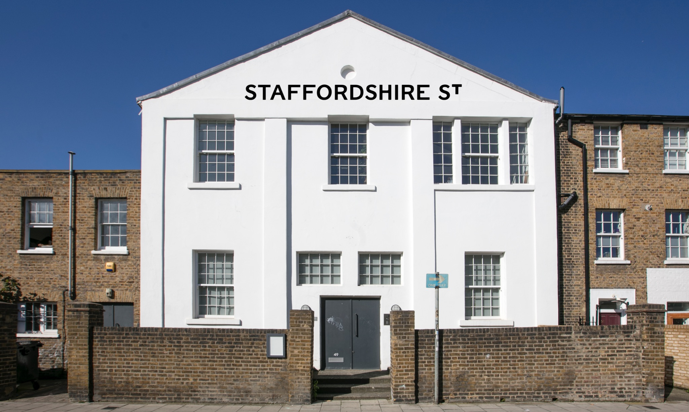Name

Title of the project

Brief description of the project max. 100 words
A clear sentence or two, an elevator pitch which encapsulates the project.

Proposal
max. 300 words
Tell us what you want to do. Your proposal should outline your approach, what work you propose to present or produce. We want to hear about the context and materiality of the event. How does your event align with our programme at Staffordshire St?

Collective or Curator Statement and Biography max. 200 words
Brief introduction about you and your wider practice. Please provide any examples of previous work/workshop/facilitation/your organisation has undertaken

List of Collaborators:
Artists, curators, performers & their role in the project and link to their work. Please state if these collaborators are confirmed or unconfirmed

Name | Role | Status
 |  | Ideal
 |  | Expected
 |  | Confirmed
 |  | Confirmed
 |  | Confirmed

Installation / AV requirements
Please describe the set up requirements for the event. ie chairs, tables, projector, mics etc. Please state who will be installing and their experience or whether you will need to book staff time, this may come at an additional cost.

Audience & Budget:
How many people, ideally, do you expect to attend your event/s? Describe how you will raise income to cover costs. Income: 100 tickets @ £10.00 Expenses: 5 performers @ £60 and who your target audience is eg: 16-24 yr olds, students.

Portfolio:
max. 4 pages. or 3 min video (include a link)
Examples of previous work by those involved in the exhibition or examples of plans for work that will be produced for the show.
We strongly suggest you think about how you will engage with the space and you may wish to include supplementary drawings or preparatory sketches to indicate a mock up of how you will use the space as appropriate to your project.

